**Problem 1:**

File : Problem_1\src\university\course\Course.java

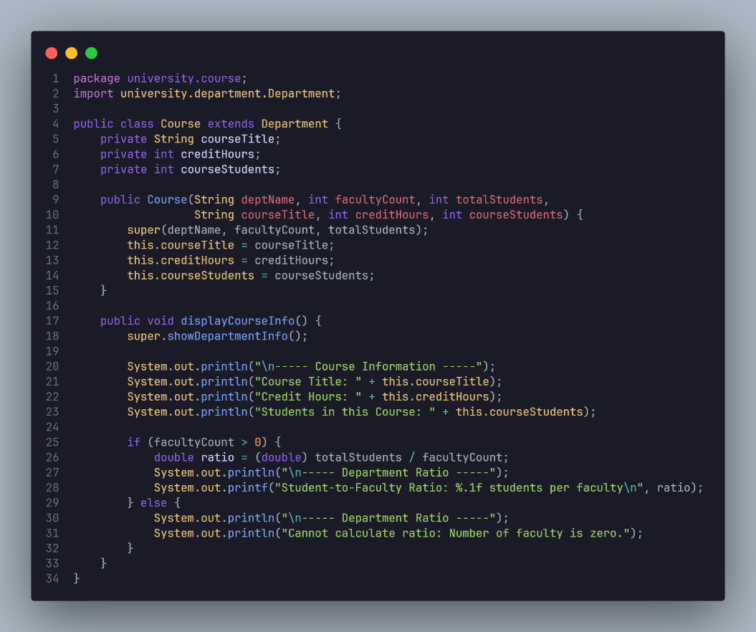

File : Problem_1\src\university\department\Department.java

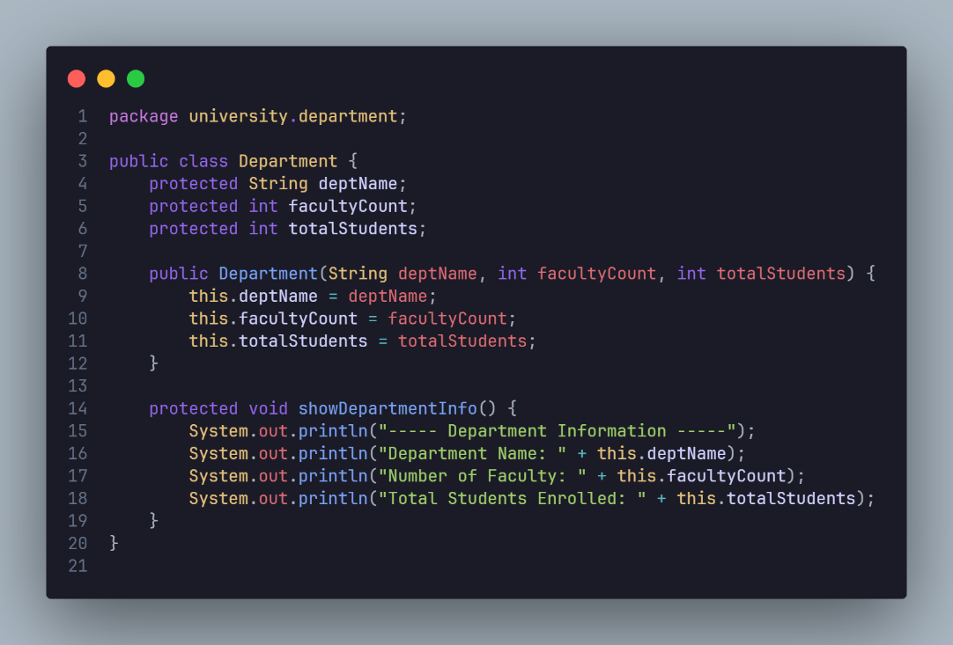

File : Problem_1\src\Main.java

Problem 2:

File : Problem_2\src\Colour.java

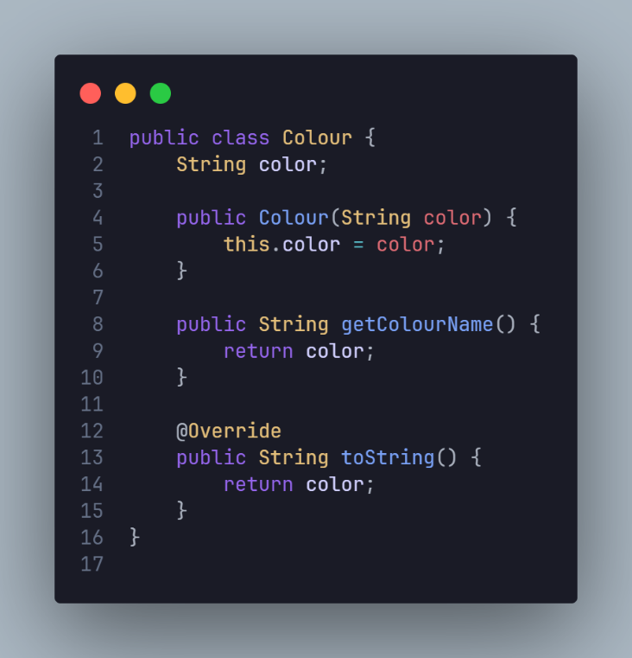

File : Problem_2\src\Product.java

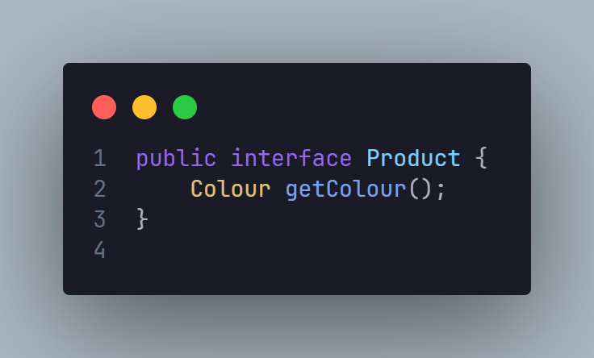

File : Problem_2\src\Shelf.java

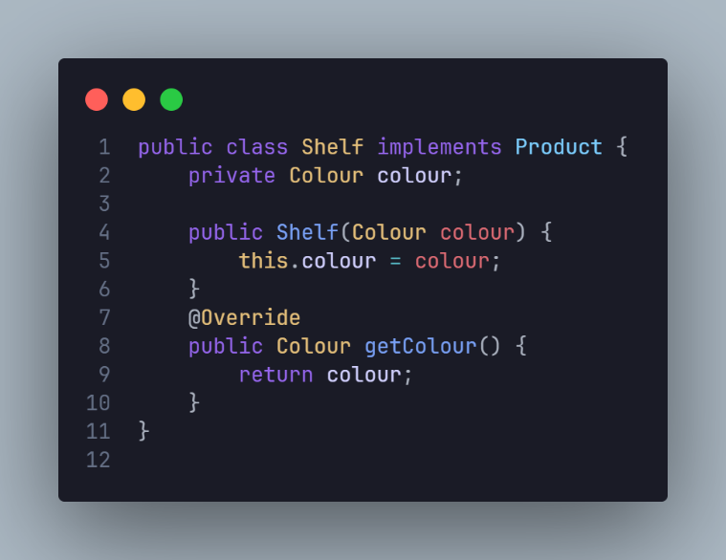

File : Problem_2\src\Desk.java

File : Problem_2\src\Main.java

Problem 3 :

File : Problem_3\src\package1\Laibrary.java

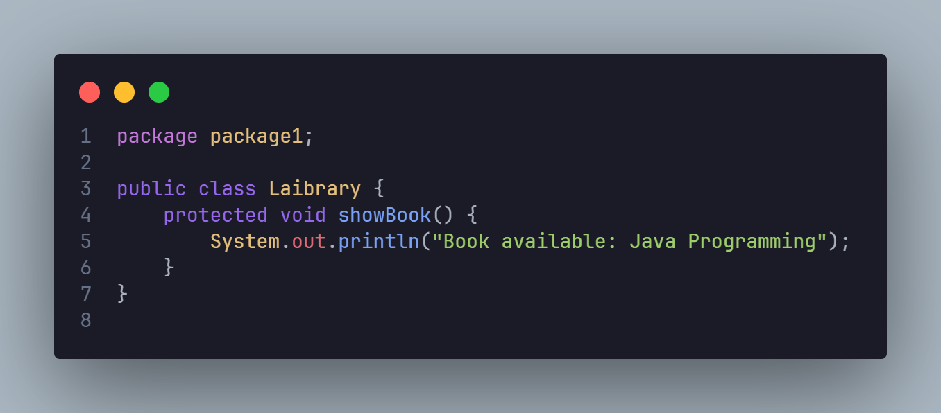

File : Problem_3\src\package2\Reader.java

File : Problem_3\src\package2\MainClass.java

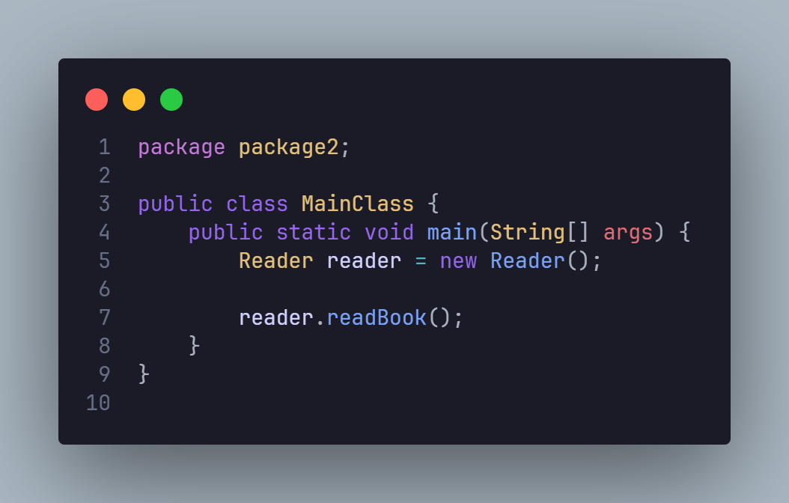

Problem 4 :

File : Problem_4\src\Payment.java

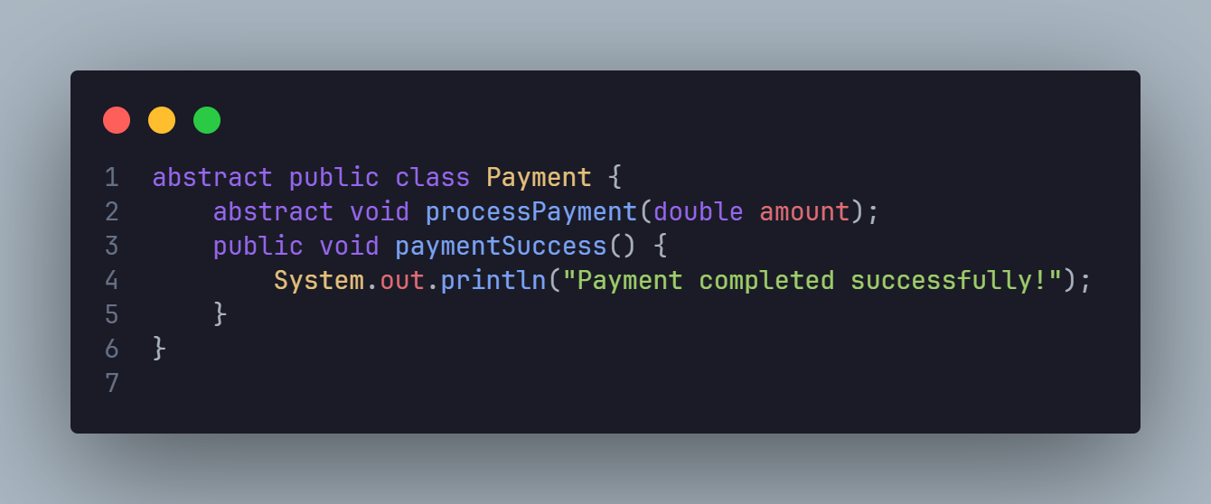

File : Problem_4\src\CreditCardPayment.java

File : Problem_4\src\MobileBankingPayment.java

File : Problem_4\src\Main.java

